**CN LAB WEEK 4**

**Implementation of Local DNS Server and Authoritative Nameserver**

|  |  |  |  |
| --- | --- | --- | --- |
|  | SRN: PES1UG20CS484 | Section: H | Roll No: 40 |

**Observation 1**

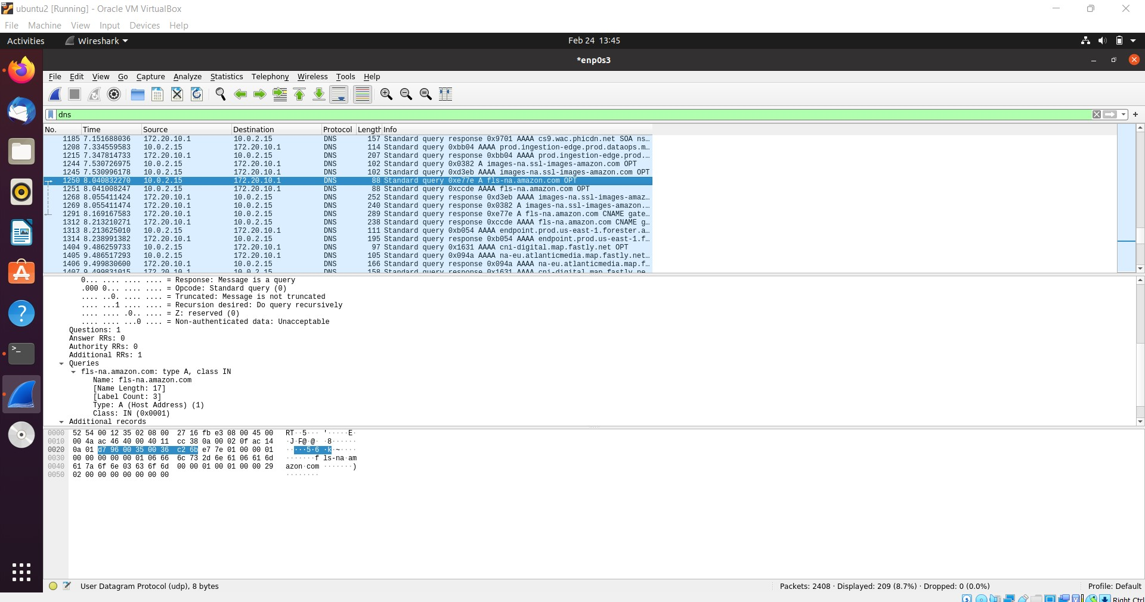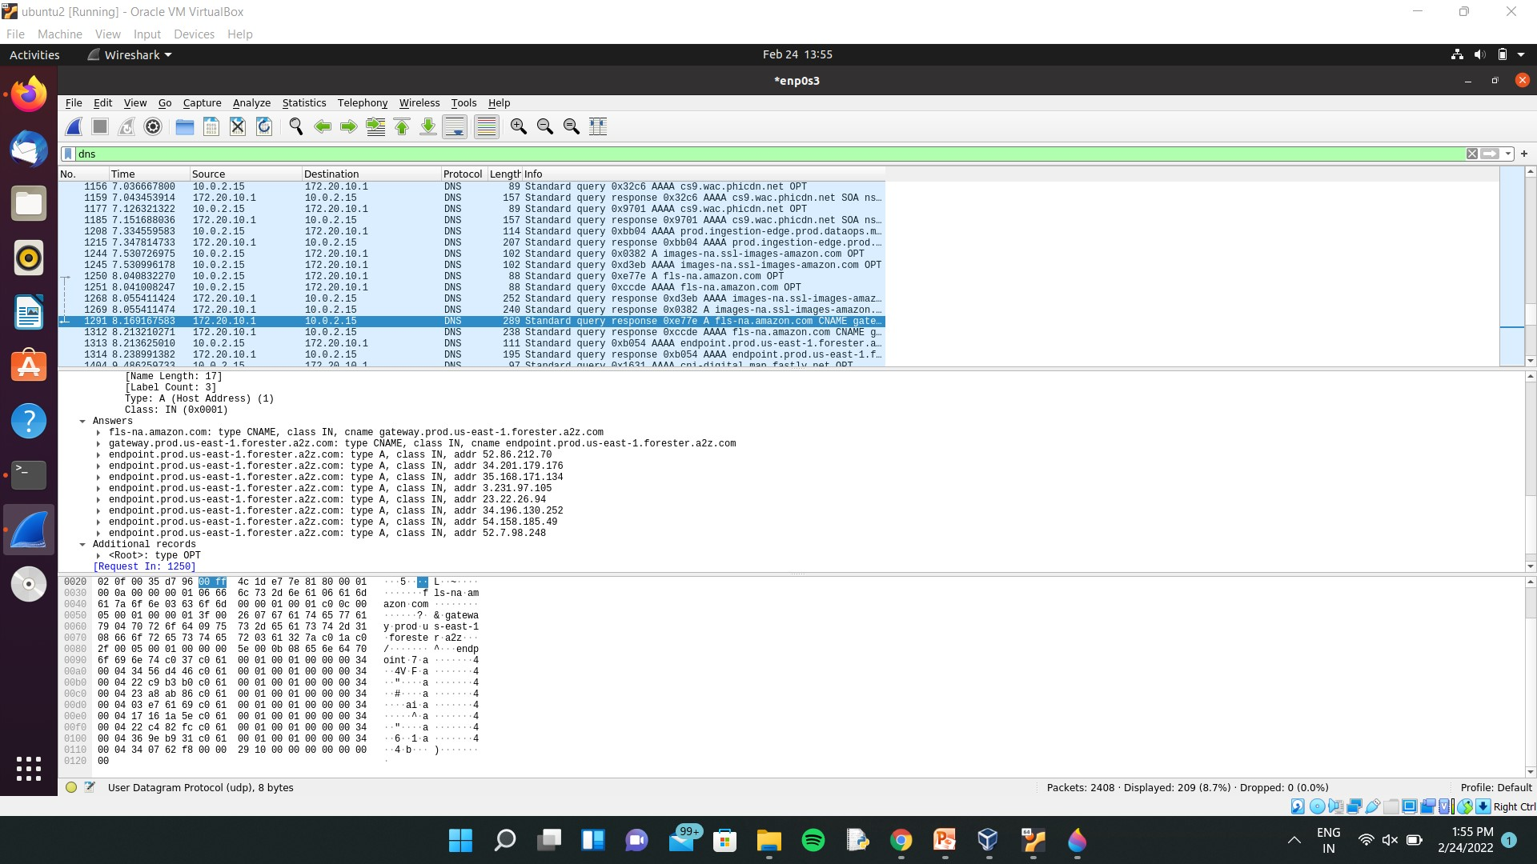

**Task 1**

**Observation 2**

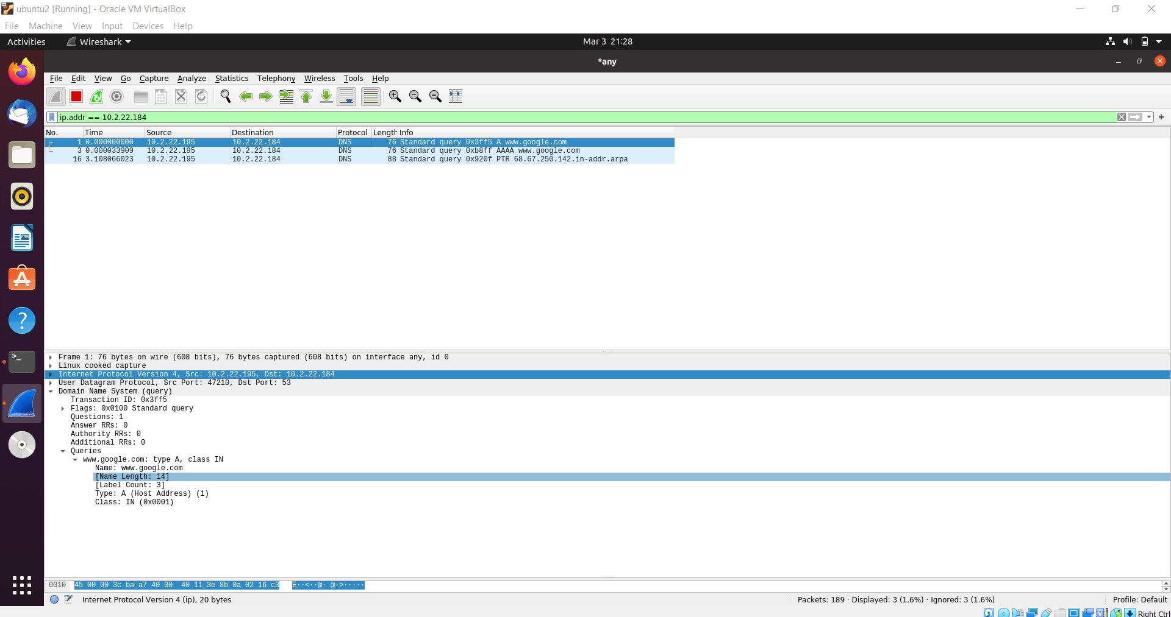

**Observation 3**

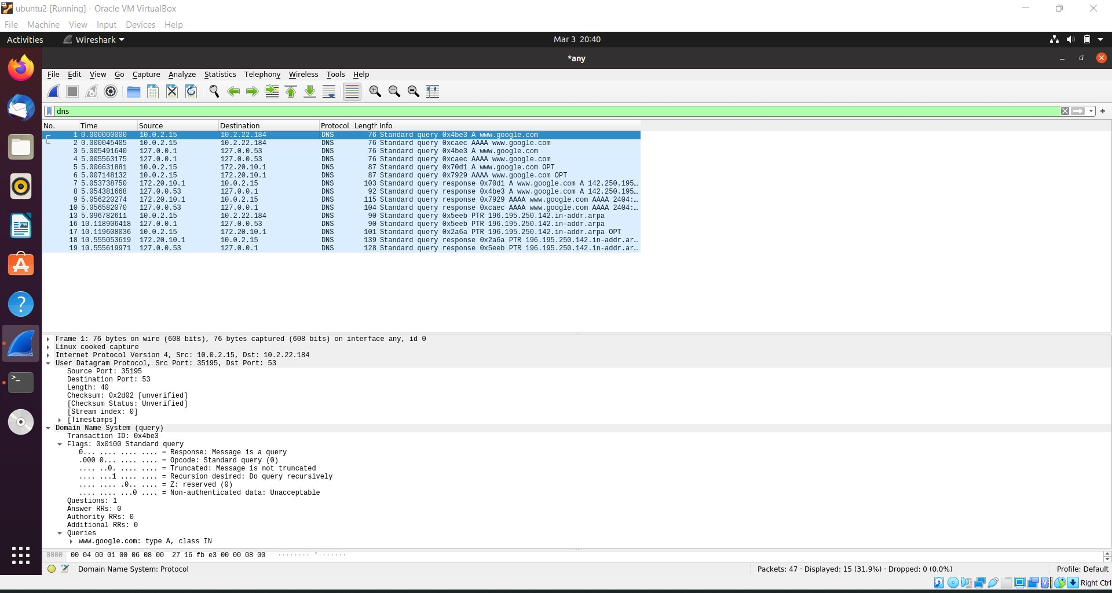

**Observation 4**



